Proposal Camping Version

Table of Contents

1.Case 1

2.Functions 1

2.1 User Side 1

2.2 Administrator side. 1

3. Open Questions 2

4.Alternative Hardware 2

# 1.Case

The customer has a (small) laundromat available in his business that uses coin boxes. The customer wants to digitalize the payment process because he/she doesn’t want the hassle of using coins.

# 2.Functions

## 2.1 User Side

1. The customer scans a QR code that is placed on the machine.
2. The user sees the amount he needs to pay and chooses the payment option he wants to use.
3. User pays, if not succeeded the payment page should return if desired.
4. If payment is succeeded A “Payment Done” page should be loaded.

## 2.2 Administrator side.

1.Posibillty to set location as onetime use.

2. Possibility to generate a specific QR code for the desired machine.

3. Possibility to alter the landings page if the payment is successful done.

4. Possibility to alter the landings page if the payment is not successfully done.

# 3. Open Questions

1. Is it preferred to have a “Done” signal if so, we need a lot more hardware which is not cost saving?
2. Does the operator have access to the admin panel?
3. Is refunding a possibility if the machine does not start?

# 4.Alternative Hardware

The Extended Gateway Console for Pay2wash costs around 450 euro in parts. This includes the possibility for a feedback signal better known as the done signal. And Excludes Labor.

If we don’t use the feedback signal it is possible to reduce the hardware which will lead to a smaller console

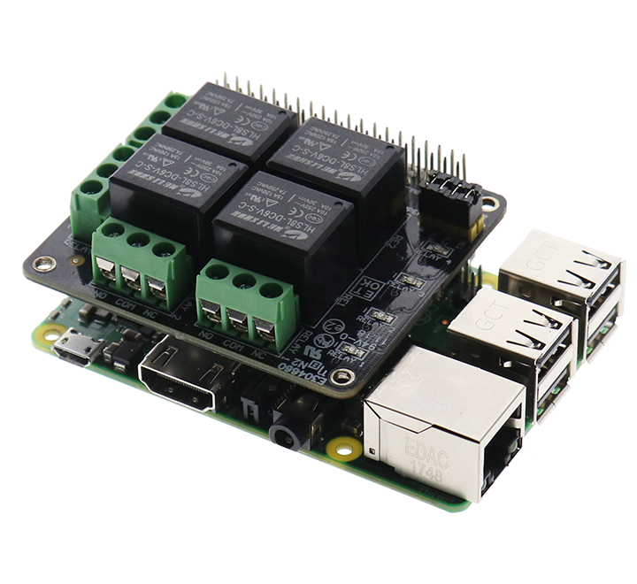

If we use a on shield relay board, we don’t have to make wire connections internally to connect the raspberry to the relays. One of the cost risers are the interface relays, you need one for every machine and one piece costs around 15 euro. In Some previous projects we used a smaller case from the brand Rittal that is cheaper than the bigger FiBOX and is completely made from metal.

Cost Breakdown Smaller box

|  |  |
| --- | --- |
| Rittal Case | 30 |
| Raspberry pi | 30 |
| Sd card | 10 |
| Power supply 5V | 15 |
| Connection Clamps | 15 |
| Relays Shield | 20 |
| Pi Holder | 10 |
| **total** | **130** |

When we compare to the standard console the “simple one” costs 320 euro less. Not even speaking about the labor that is needed to build the simple one.